My Preferences

- Create a single view iphone project named: MyPreferences
- Add Delegate Code
- Add Controls
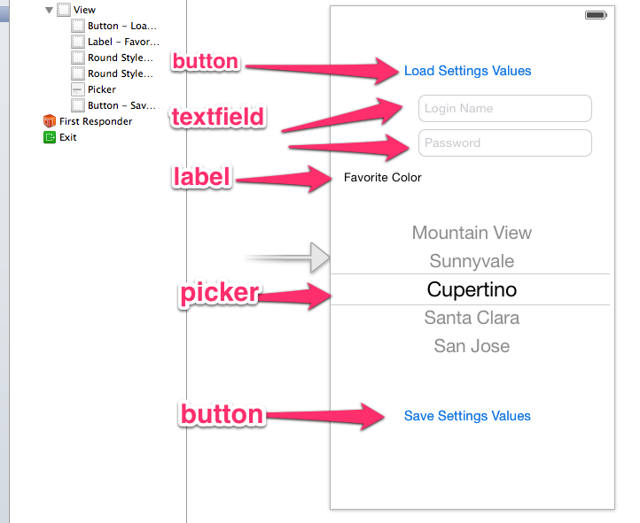
Add Outlets and Actions
@property (nonatomic, retain) UITextField *loginName;
@property (nonatomic, retain) UITextField *password;
@property (nonatomic, retain) UIPickerView *favoriteColor;

-(IBAction) loadSettings: (id) sender;
-(IBAction) saveSettings: (id) sender;
-(IBAction) doneEditing: (id) sender;

- Add Code to .m
NSMutableArray *colors;
NSString *favoriteColorSelected;

-(IBAction) doneEditing:(id) sender {
[sender resignFirstResponder];
}

…the rest from example
- Bind donediting to textfields
- Add Settings
